*STORED PROCEDURE*

USE [Student]

GO

/****** Object: StoredProcedure [dbo].[sp_student] Script Date: 8/23/2022 10:40:33 AM ******/

DROP PROCEDURE [dbo].[sp_student]

GO

/****** Object: StoredProcedure [dbo].[sp_student] Script Date: 8/23/2022 10:40:33 AM ******/

SET ANSI_NULLS ON

GO

SET QUOTED_IDENTIFIER ON

GO

CREATE procedure [dbo].[sp_student]

(@id int=0,

@name varchar(50)='',

@rollno numeric(3,0)=0,

@Address text='',

@state varchar(50)='',

@dob date='',

@Flag varchar(50)=''

)As

BEGIN

IF @Flag='Insert'

BEGIN

INSERT INTO Student(Name,Rollno,Address,State,DOB) values(@name,@rollno,@Address,@state,@dob)

END

ELSE IF @Flag='Update'

BEGIN

update Student set Name=@name,Rollno=@rollno,Address=@Address,State=@state,DOB=@dob where ID=@id;

END

ELSE IF @Flag='Delete'

BEGIN

Delete from Student where ID=@Id;

END

ELSE IF @Flag='Select'

BEGIN

select * from Student where ID=@Id;

END

ELSE IF @Flag='Select_all'

BEGIN

select * from Student

END

END

GO

*Insert*

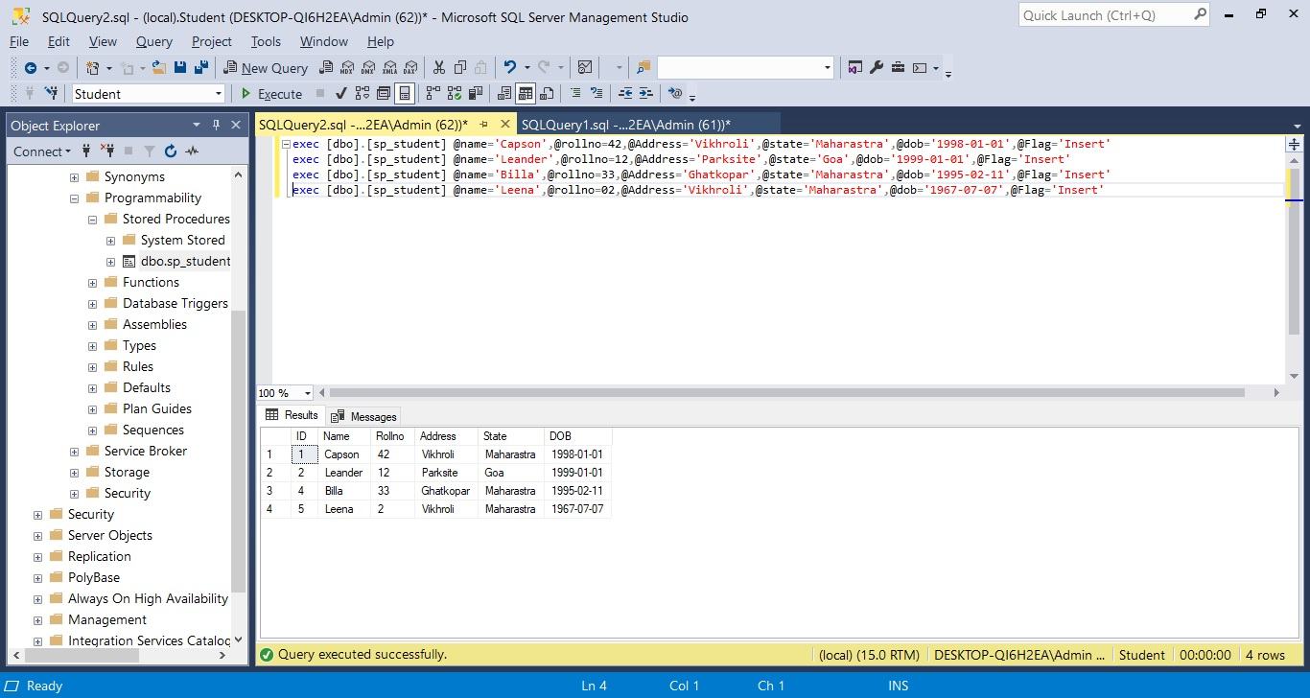

Commands: -

* exec [dbo].[sp_student] @name='Capson',@rollno=42,@Address='Vikhroli',@state='Maharastra',@dob='1998-01-01',@Flag='Insert'
* exec [dbo].[sp_student] @name='Leander',@rollno=12,@Address='Parksite',@state='Goa',@dob='1999-01-01',@Flag='Insert'
* exec [dbo].[sp_student] @name='Billa',@rollno=33,@Address='Ghatkopar',@state='Maharastra',@dob='1995-02-11',@Flag='Insert'
* exec [dbo].[sp_student] @name='Leena',@rollno=02,@Address='Vikhroli',@state='Maharastra',@dob='1967-07-07',@Flag='Insert'

*Update*

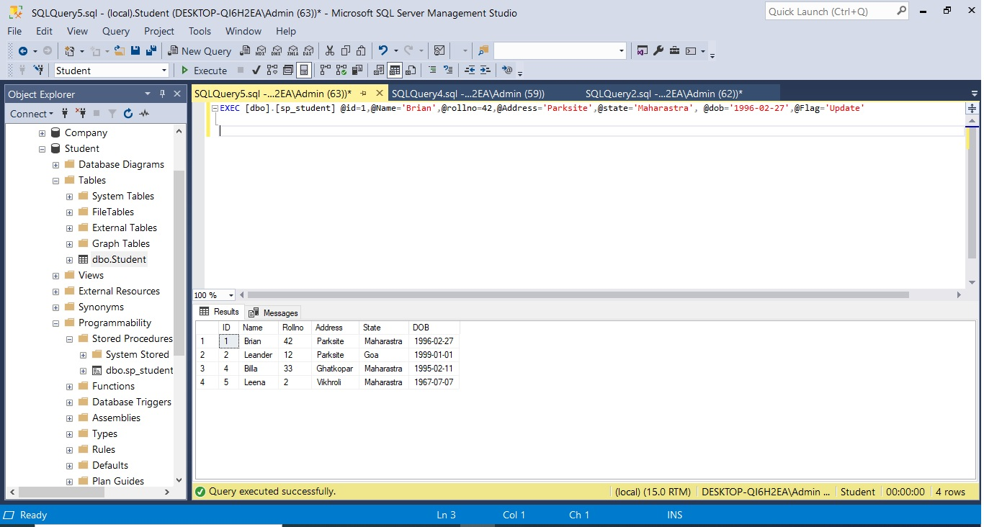

Commands: -

* EXEC [dbo].[sp_student] @id=1,@Name='Brian',@rollno=42,@Address='Parksite',@state='Maharastra', @dob='1996-02-27',@Flag='Update'

*Delete*

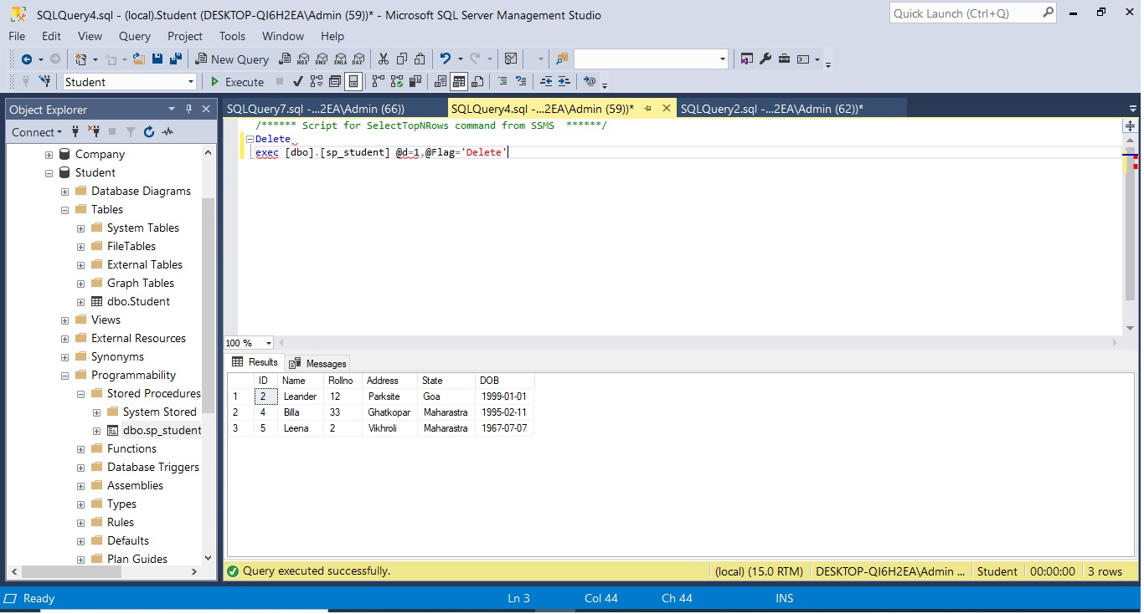

Commands: -

* exec [dbo].[sp_student] @d=1,@Flag='Delete'

*Select*

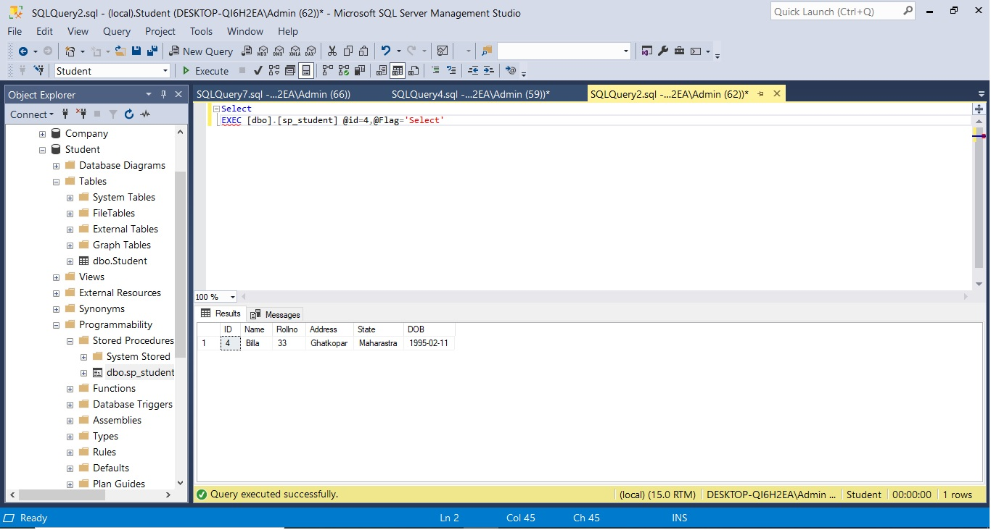

Commands: -

* EXEC [dbo].[sp_student] @id=4,@Flag='Select'